Daniel Ocampo

FS 201

Professor. Utz

May, 8 2016

My Infographic

The basic idea is to make an infographic of water pollution for kids. Due to the fact that kids have a short attention span, I feel that the image should flash the most important information.

Therefore I only put information of how it affects humans as a hook. While then transitions to how it affects fish. Then I start to describe why it affects fish by adding a storm drain and chemicals that affect the fish. Then, I make the person think on what he or she should do to solve this issue. To talk to adults, and find a solution, or a conversation starter with friends in how to solve the issue.

When creating this infographic I wanted to show some data chart so kids could see what was on based on data. After reviewing the data chart, that I had created it did not seem appealing to myself, I didn't think it would looking appealing to young children from the ages of 5-8.

In **Figure. 1,** we the a sample of one the bar charts that shows the level of pollutants of the most polluted places in America. Please note that anything over 4 would unhealthy for the consumer.

After doing some primary research asking my nephews, cousins, and some of their friends none of them could understand the simple bar graph to my infographic. Therefore the modifications from my infographic stayed the same. Next, I did research on color because of simple fact that certain colors attract people. For example, When people see the color blue they are given that the perception of being cool or hip. Which make sense considering the fact many social media's use that color, in having great success in attracting users.

The a step was also taken was picking cartoons that children would enjoy, after trying to create my own cartoons I decided to just go to YouTube videos with the most view in the topic of water pollutions. Taking screenshots and and editing out graphics using Gimp editor I was able to create nice cartoons for my info graphic. Finding data was the easy part because there was so many sources for water pollution, most of my sources came from articles, due to fact of time constraints of reading research articles. There are many problems with water pollution more than I had ever anticipated.

The current problem about water pollution is the simple fact that their is no simple way to answer this question. Yes there have been many ways to reduce water pollution by education, laws, and economics. One of the major factor to why there is a lot pollution is simply because people just don’t know. That why educating them while they are young is essential. The main goal of this infographic is to introduce the problem as simple as possible so any 5 year old can understand it. The infographic is an introduction to water pollution for children at a young age. In hopes that they will think about it and discusses with their parents and friends.

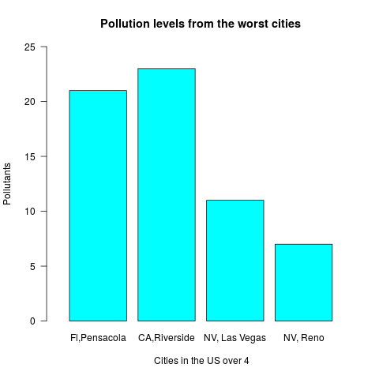

**Figure 1**: This data chart was created using R-Studio to display the data from **Figure 2,** in a simple form.

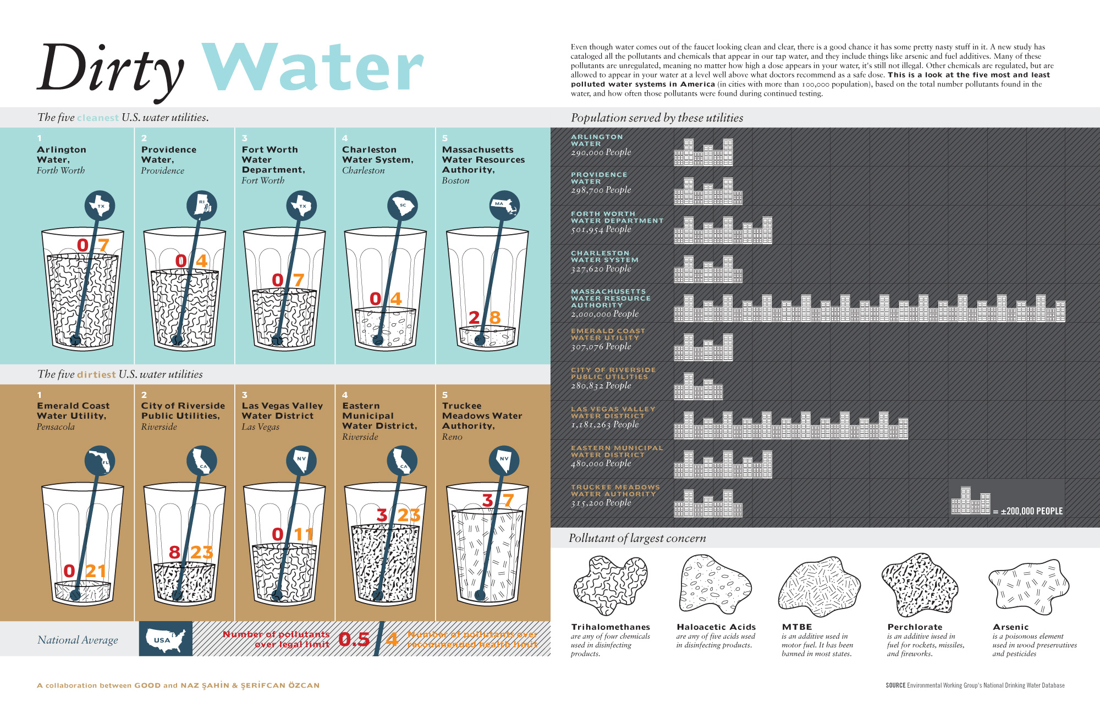

Figure:2 Data that was found during my research(3)

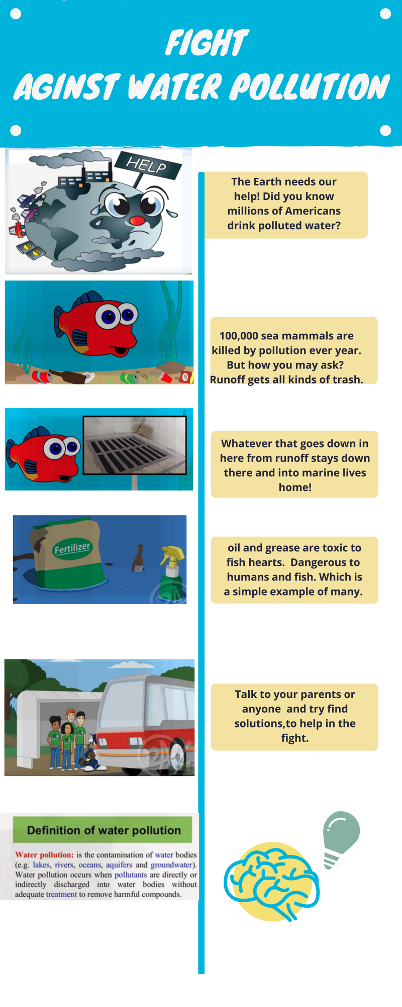

**Figure 3**: This is the infographic.(2,3,4,5,7)

Works Cited

1. McSpadden, Kevin. "You now have a shorter attention span than a goldfish." *Time Online Magazine. Retrieved May* 7 (2015): 2016.
2. Yamada, Yuki, and Takahiro Kawabe. "Emotion colors time perception unconsciously." *Consciousness and cognition* 20.4 (2011): 1835-1841.
3. Wright, Paul. "5 Infographics That Show The Need For Drinking Water Testing." *Answers for Science. Knowledge for Life.* Sciex, 7 Mar. 2016. Web. 08 May 2017.
4. Duhigg, Charles. "Millions in U.S. Drink Dirty Water, Records Show." *The New York Times*. The New York Times, 07 Dec. 2009. Web. 08 May 2017. <http://www.nytimes.com/2009/12/08/business/energy-environment/08water.html>.
5. Kassoy, Ben. "11 Facts About Pollution." *DoSomething.org | Volunteer for Social Change*. Non-profit , n.d. Web. 08 May 2017.https://www.dosomething.org/us/facts/11-facts-about-pollution
6. Woodford, Chris. "Water pollution: An introduction to causes, effects, solutions." *Explain that Stuff*. N.p., 05 June 2016. Web. 08 May 2017. <http://www.explainthatstuff.com/waterpollution.html>.
7. Geck, Brian. "Freddy the Fish Teaches About Stormwater." *YouTube*. North Central Texas Concile of Governments , 08 Dec. 2014. Web. 08 May 2017. <https://www.youtube.com/watch?v=jjPfLhJbdc0>.
8. Smartlearningforall. "Water Pollution for Kids." *YouTube*. Smart Learning for all, 03 Feb. 2015. Web. 08 May 2017. <https://www.youtube.com/watch?v=93BqLewm3bA>.